Module 6) JAVASCRIPT BASIC & DOM

**Q.1** What is JavaScript. How to use it?

**A-1)** JavaScript (JS) is a computer programming language used to make websites and

applications dynamic and interactive.

It’s unique because it can run directly in your browser, not just on a server.

Along with hypertext markup language (HTML) and cascading style sheets (CSS),

JavaScript is one of the most commonly used programming languages of the internet.

### Q.2 How many type of Variable in JavaScript? A-2) Variables are Containers for Storing Data

There are 4 types of variable in javascript.

* Automatically
* Using var
* Using let
* Using const

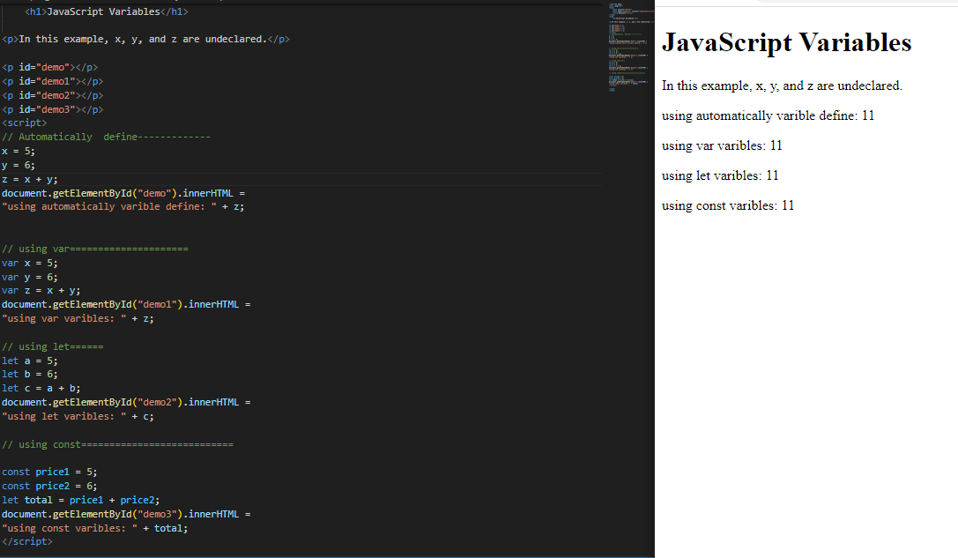

**Q.3)** Define a Data Types in js?

**A-3)** Data types in JavaScript define the data type that a variable can store.

JavaScript includes **primitive** and **non-primitive** data types.

1)The **primitive** data types in JavaScript include **string, number, Boolean, undefined,**

**null, and symbol.**

2)The **non-primitive** data type includes the **object, an array, an date.**

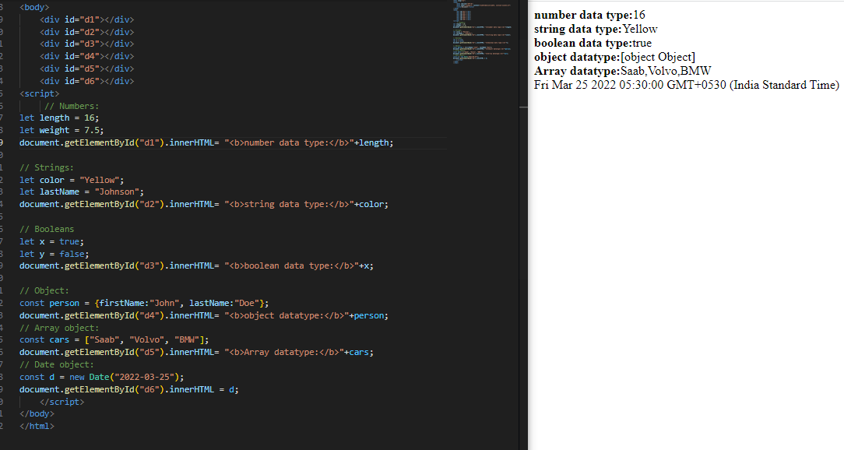

**Q.4)** Write a mul Function Which Will Work Properly When invoked with Following Syntax.

**A-4)** in JavaScript, "MUL" is not a specific built-in function or keyword. However, if you are referring to the "mul" operation, it is likely related to multiplication.

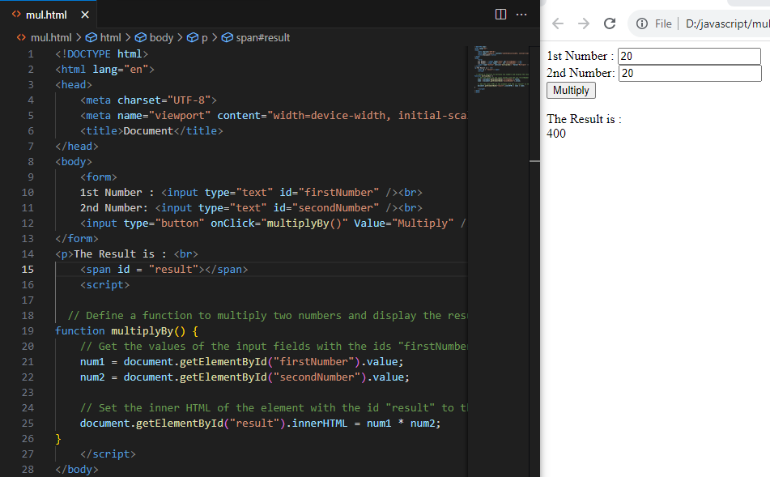

**Q.5)** What the deference between undefined and undeclared in JavaScript?

**A-5)** **Undefined:**It occurs when a variable has been declared but has not been assigned any value. Undefined is not a keyword.

A Variable is Undefined if it hasn’t been declared with an appropriate keyword.

for Example: var , let , const.

Accessing an undeclared variable will throw a ReferenceError.

Example**: console.log(x);//ReferenceError:x is not defined**

**Undeclared:**It occurs when we try to access any variable that is not initialized or declared earlier using the *var* or *const keyword*.

A Variable is Undefines if it hasn’t been assigned a value.undefined is a primitive data type in javascript and represent the absence of a value intentional or otherwise.

Example:**let x;**

**console.log(x);// undefined**

**Q.6)** Using console.log() print out the following statement: The quote 'There is no exercise better for the heart than reaching down and lifting people up.' by John Holmes teaches us to help one another. Using console.log() print out the following quote by Mother Teresa:

**a-6)**

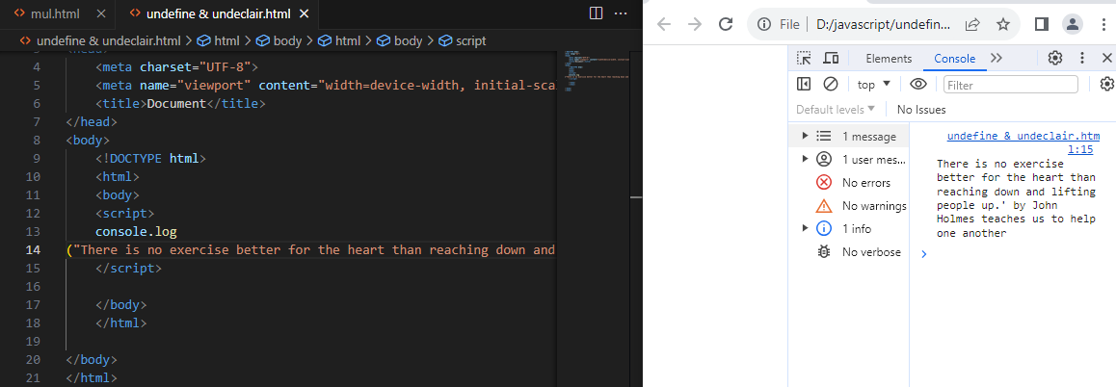

**Q.7)** Check if typeof '10' is exactly equal to 10. If not make it exactly equal?

**A-7)**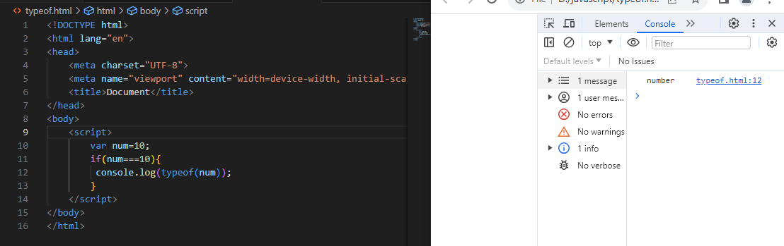

Q.8 Write a JavaScript Program to find the area of a triangle?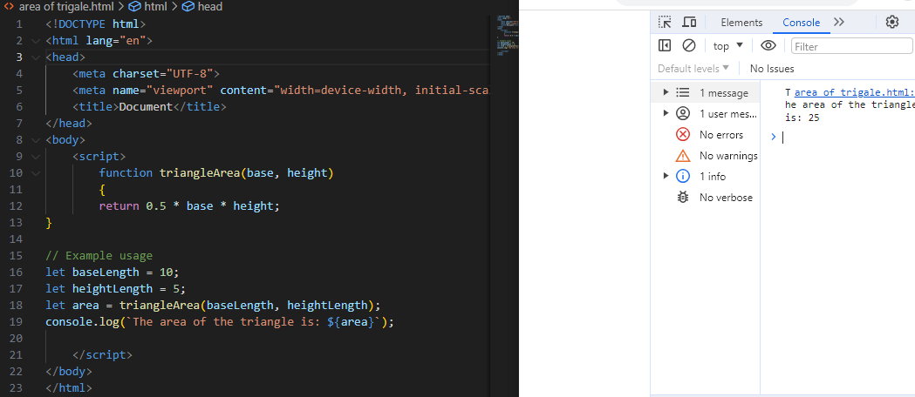

Q.9 Write a JavaScript program to calculate days left until next Christmas?

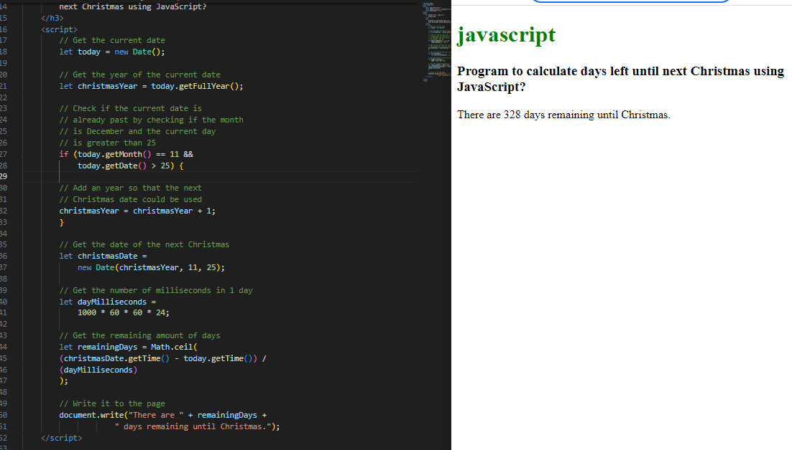

**Q.10)** What is Condition Statement?

**A-10)**Sometimes we might have to execute a code based off some condition.

for Example:a Promt might ask for age of the used and if its grate display a special

message.

in A JAvascript we have three forms of statement.

1)if statement

2)if…..elase statement

3)if……elase if …..else statement

1)if statement

->The if statement evaluated the condition inside the ().

->if the condition is evaluated to true ,the code inside the body of if executed the code is

not executed

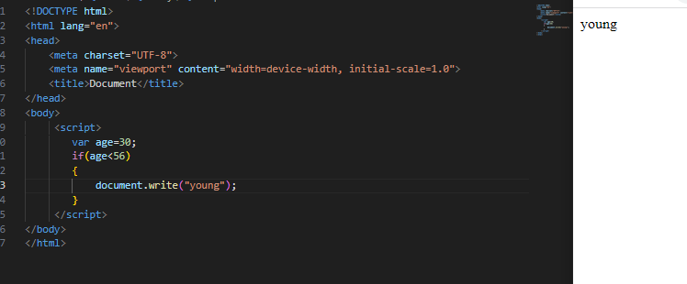

2)if…else statement

The if statement can have an optional else clues.

The symbol looks something like this.

.if the conditional is true code inside if is execute else code inside else block is execute.

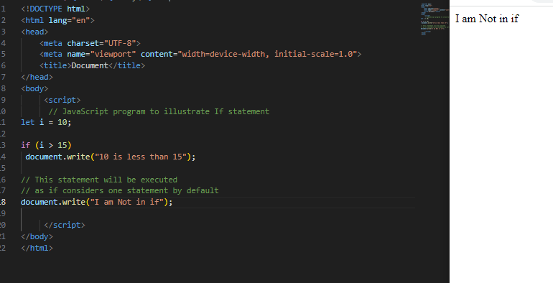

3)if..else if statement

Sometime we might want to keep rechecking a set of conditions one by until one matches.

we use if else if for achieving this.

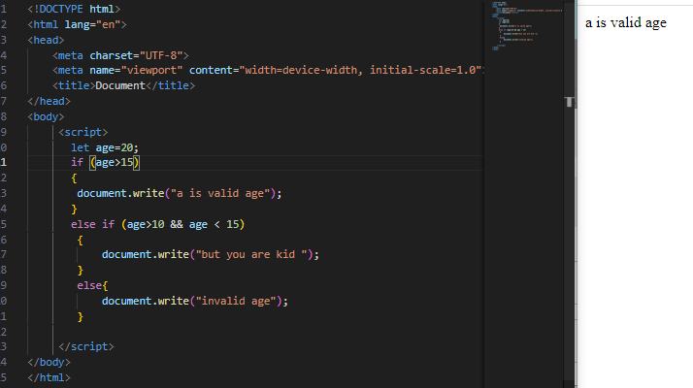

Q.11 Find circumference of Rectangle formula: C = 4 * a?

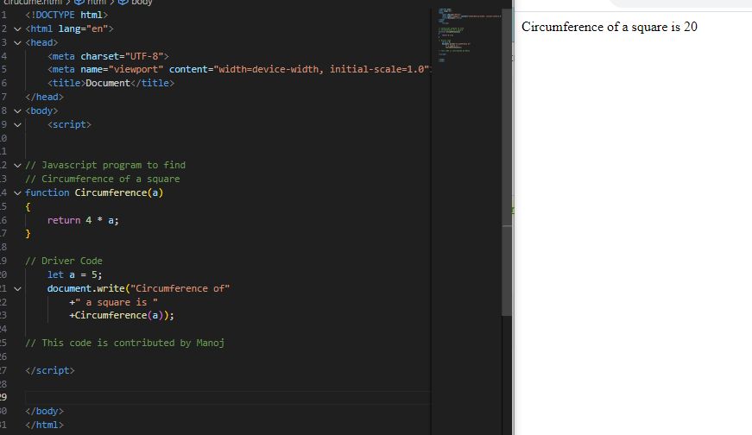

Q.12 WAP to convert years into days and days into years?

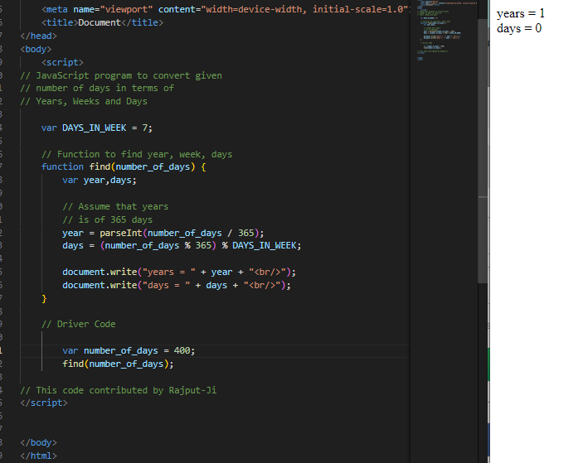

Q.13 Convert temperature Fahrenheit to Celsius? (Conditional logic Question).

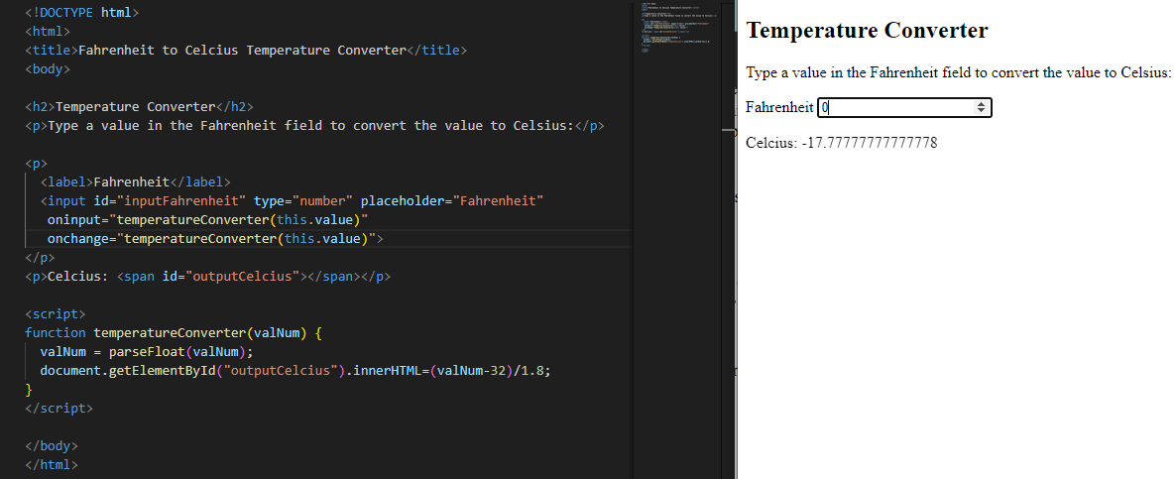

Q.14 Write a JavaScript exercise to get the extension of a filename.?

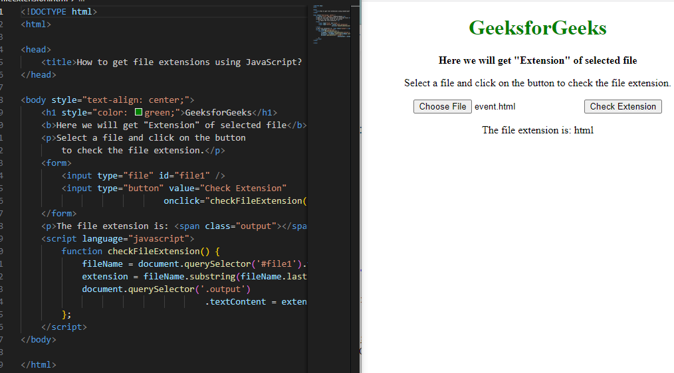

Q.15 What is the result of the expression (5 > 3 && 2 < 4)?

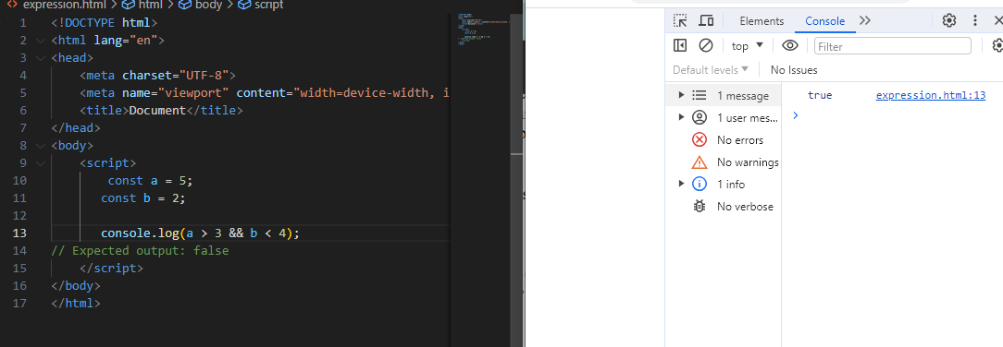

Q.16 What is the result of the expression (true && 1 && "hello")?

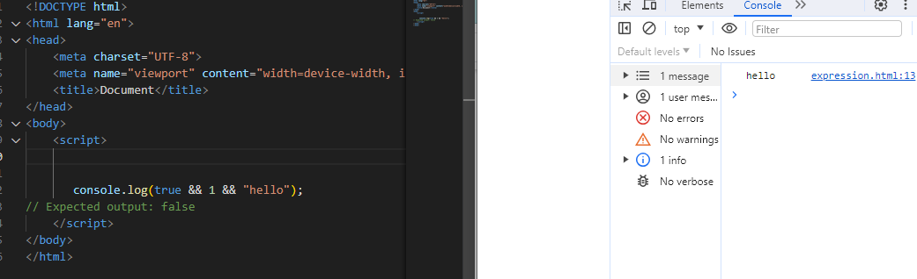

Q.17 What is the result of the expression true && false || false && true?

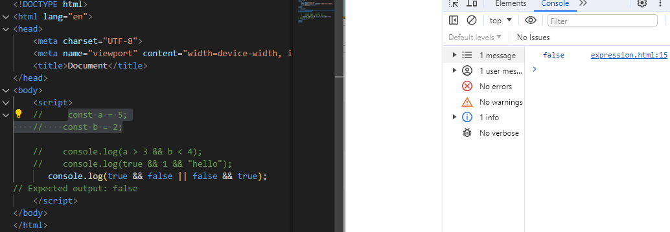

**Q.18)**What is a Loop and Switch Case in JavaScript define that?

**A-18)Loop:** we loops to perform repeated octions.for example-if you assigned a task of printing numbers from 1 to 100 it will be very hectic to do it manually ,loops help us auto such tasks.

TYPES OF LOOP:

* for loop->loop a block of code no of times.
* for in loop->loops through the keys of an object.
* for of loop0>loops through the values of an object.
* while loop->loops a block based on a specific condition.
* do-while->while loop variant which runs at least once.

Switch case:

The **switch statement** is used to perform different actions based on different conditions.

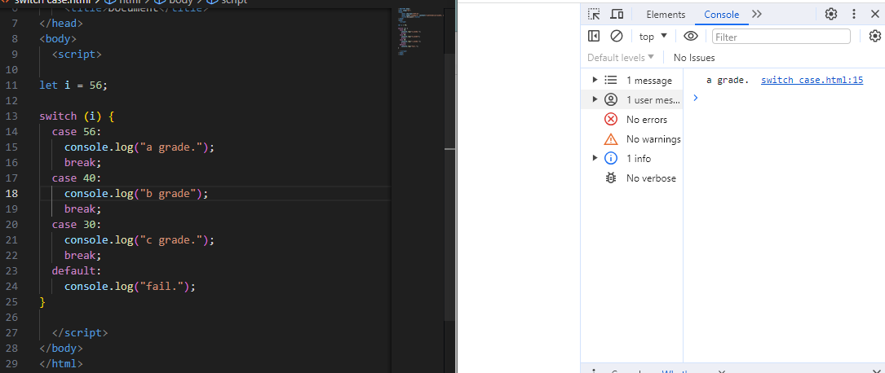

**Q.19)** What is the use of is Nan function?

**A-19)** In JavaScript NaN is short for "Not-a-Number".

The isNaN () method returns true if a value is NaN.

The isNaN () method converts the value to a number before testing it.

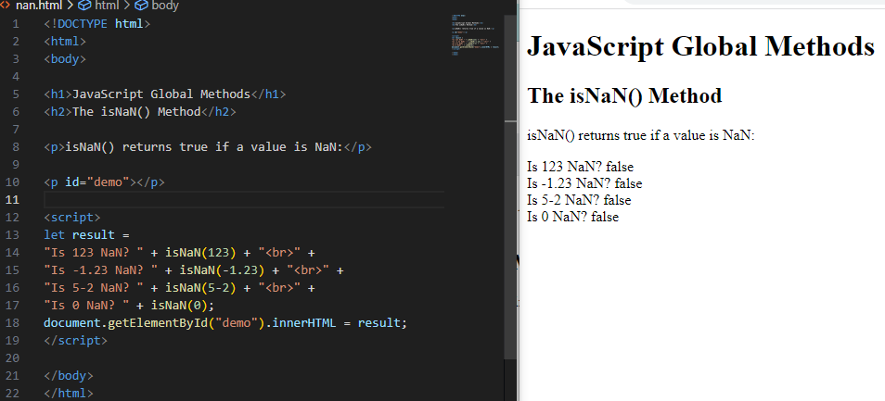

**Q.20)** What is the difference between && and || in JavaScript?

# **A-20)** **Logical AND (&&):**The **logical AND (&&)** (logical conjunction) operator for a set of Boolean operands will be true if and only if all the operands are true. Otherwise it will be false.

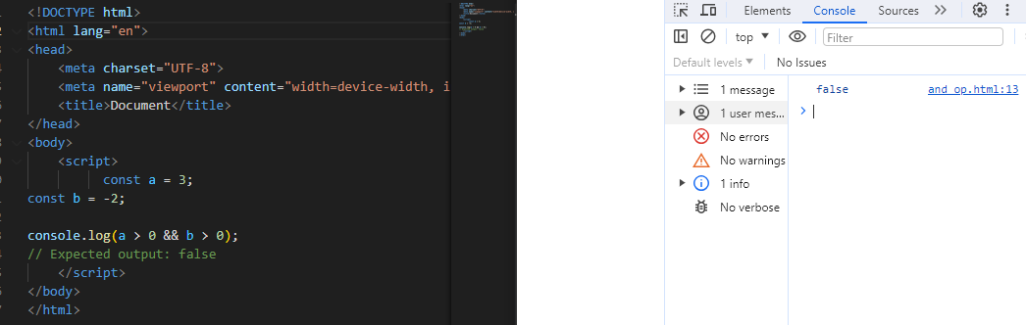

# **Logical OR (||):** The **logical OR (||)** (logical disjunction) operator for a set of operands is true if and only if one or more of its operands is true. It is typically used with boolean (logical) values. When it is, it returns a Boolean value.



**Q.21)** What is the use of Void (0)?

**A-21)** If we split this up, we have JavaScript: and void(0). Let's look at each part in more detail.

### JavaScript:

This is referred to as a **Pseudo URL**. When a browser receives this value as the value of href on an anchor tag, it interprets the JS code that follows the colon (:) rather than treating the value as a referenced path.

**void (0):**

The void operator evaluates given expressions and returns undefined.

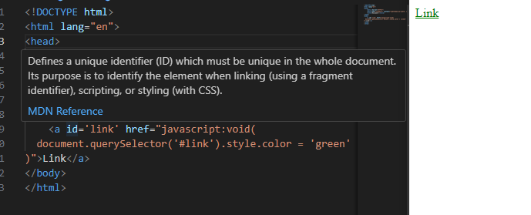

**Q.22)** Check Number Is Positive or Negative in JavaScript?

**A-22)**check the number is poditive or negative in using the math()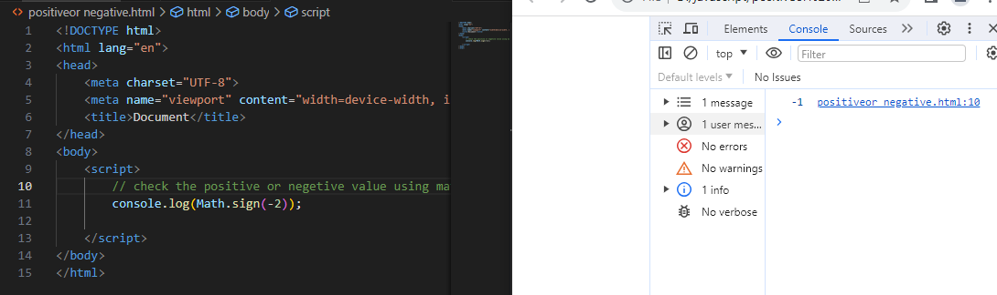

**Q.23)**Find the Character Is Vowel or Not ?

**A-23)**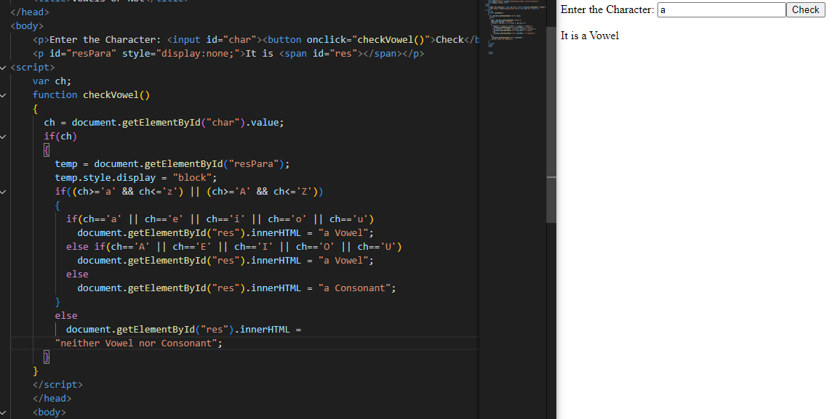

Q.24 Write to check whether a number is negative, positive or zero?

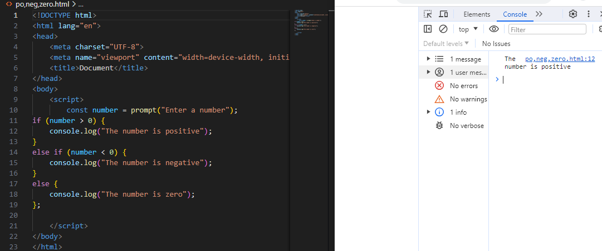

**Q-25)**Write to find number is even or odd using ternary operator in JS?

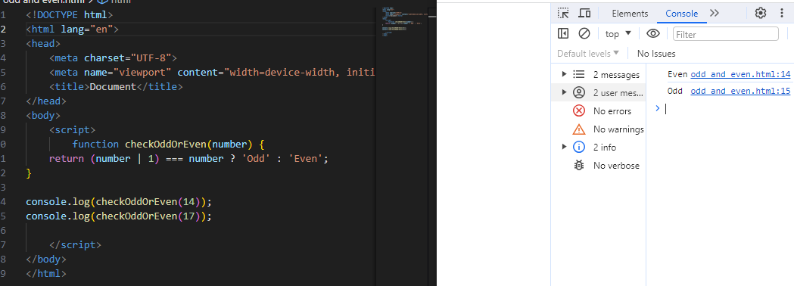

Q.26 Write find maximum number among 3 numbers using ternary operator in JS?

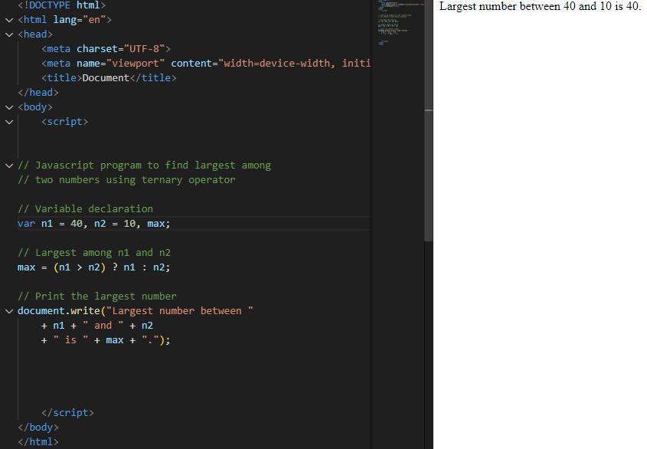

Q.27 Write to find minimum number among 3 numbers using ternary operator in JS?

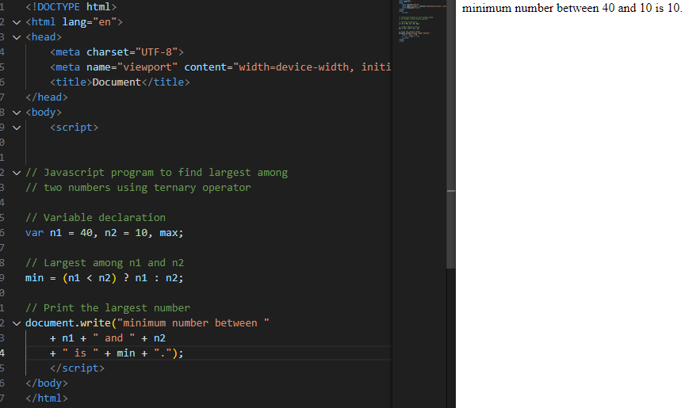

Q.28 Write to find the largest of three numbers in JS?

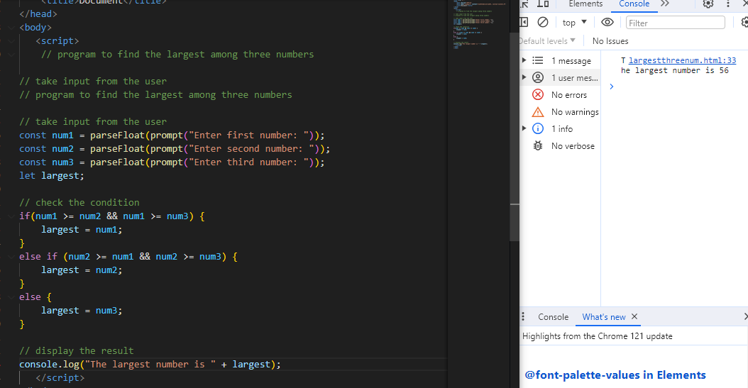

Q.29 Write to show?

i. Monday to Sunday using switch case in JS?

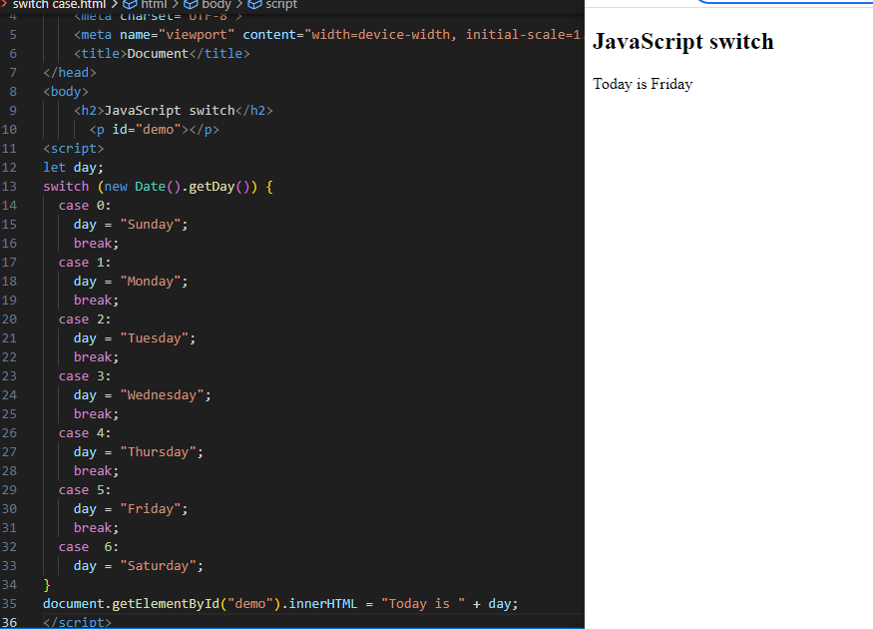

ii. Vowel or Consonant using switch case in JS?

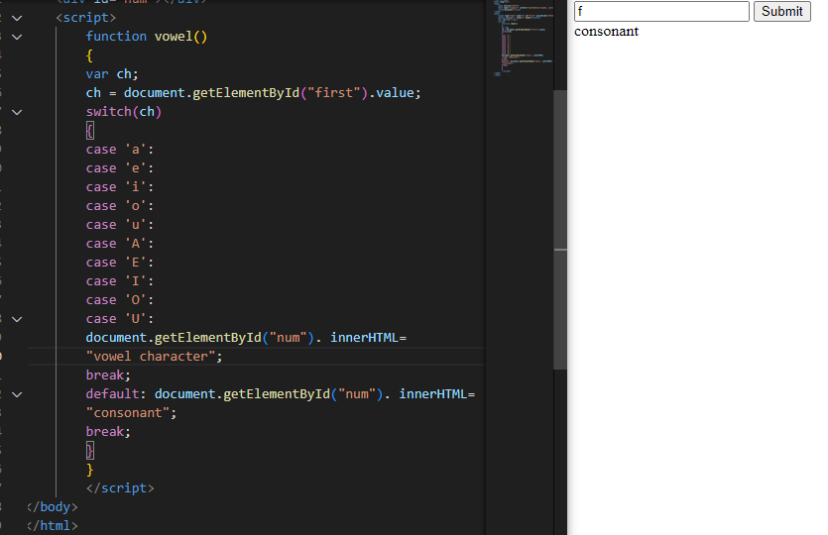

**(Conditional looping logic Question)**

**Q.30)** What are the looping structures in JavaScript? Any one Example?

**A-30)**we use loops to perform repeated actions. For example - if you are assigned a task of printing numbers from 1 to 100,it will be very hectic to do it manually, loops help us automate such tasks.

**types of loops:**

* **for loop**
* **for in loop**
* **for of loop**
* **while loop**
* **do-while loop**

**The for loop:**

the syntax of a for loop something like this.

for(statement1;statement2;statement3)

{

//code to be executed;

}

example:

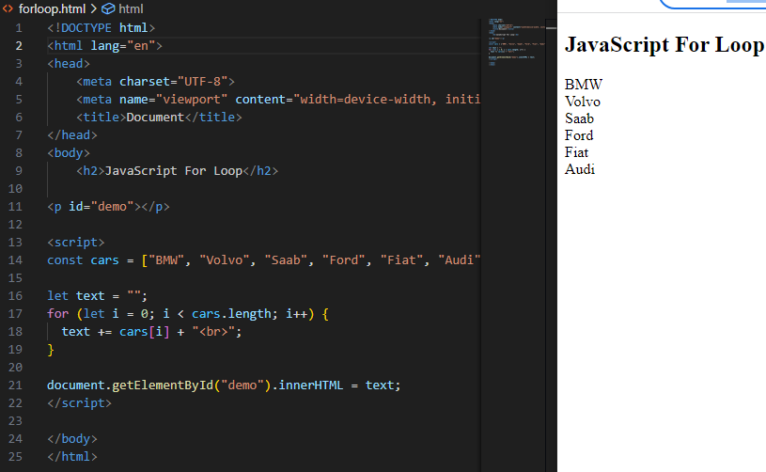

Q.31 Write a print 972 to 897 using for loop in JS?

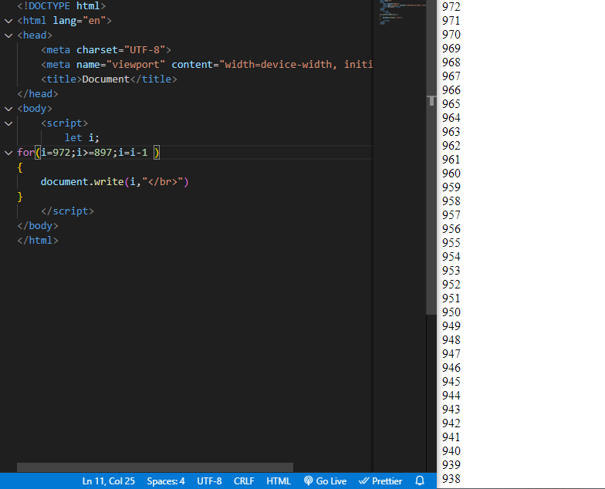

Q.32 Write to print factorial of given number?

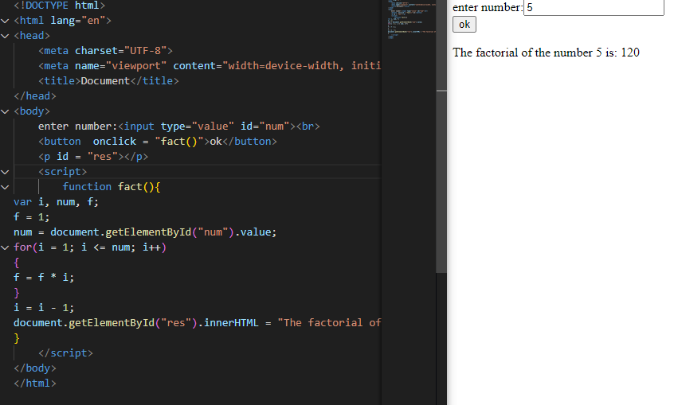

Q.33 Write to print Fibonacci series up to given numbers?

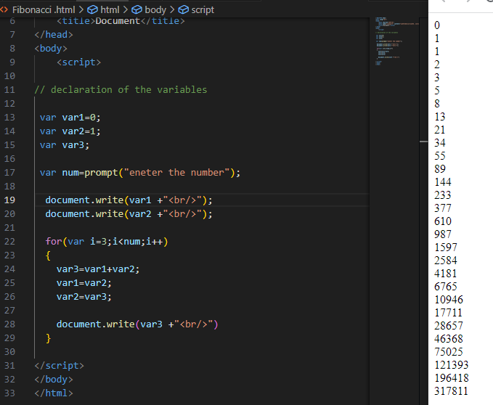

Q.34 Write to print number in reverse order e.g.: number = 64728 ---> reverse =82746 in JS?

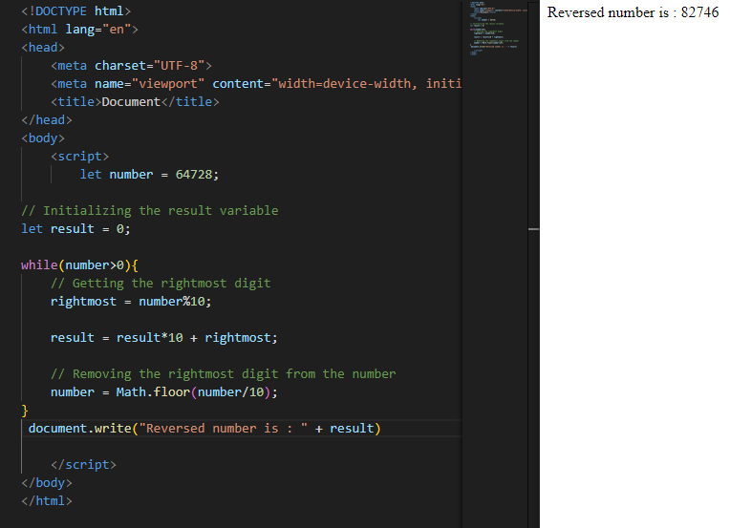

Q.35 Write a program make a summation of given number (E.g., 1523 Ans: - 11) in JS?

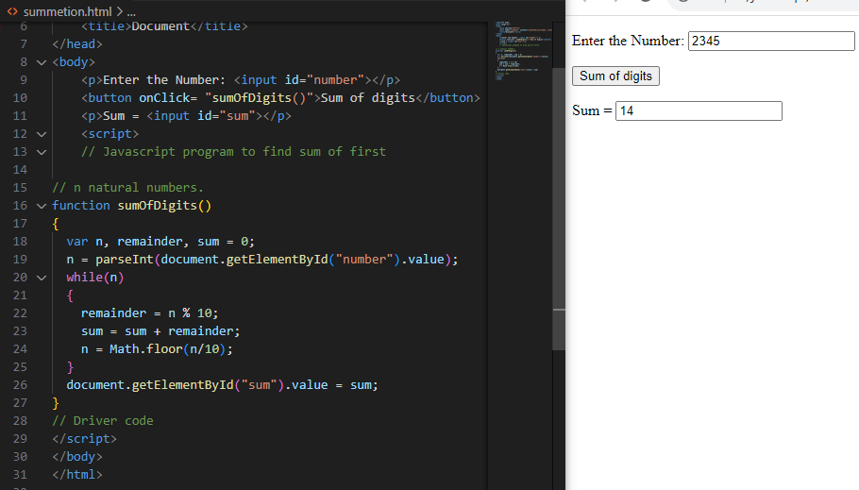

Q.36 Write a program you have to make a summation of first and last Digit.

(E.g., 1234 Ans: - 5) in JS?

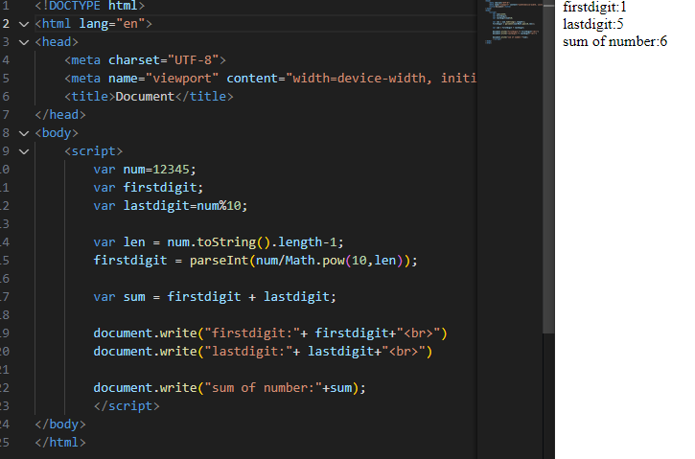

Q.37 Use console.log() and escape characters to print the following pattern in JS?

1 1 1 1 1

2 1 2 4 8

3 1 3 9 27

4 1 4 16 64

5 1 5 25 125

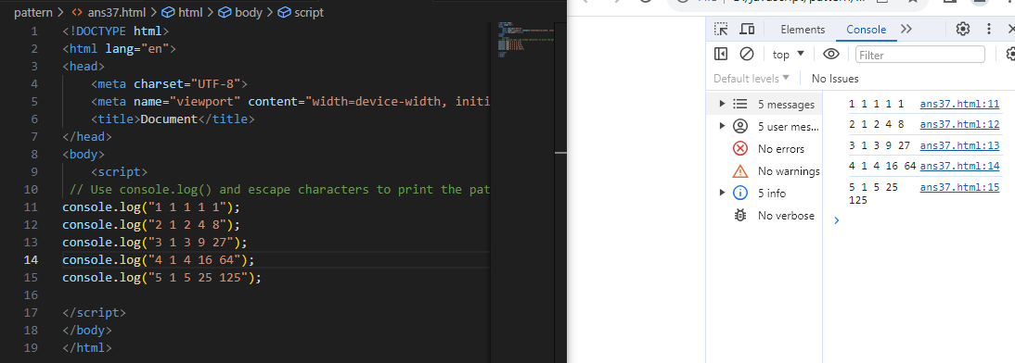

Q.38 Use pattern in console.log in JS?

1) 1

1 0

1 0 1

1 0 1 0

1 0 1 0 1

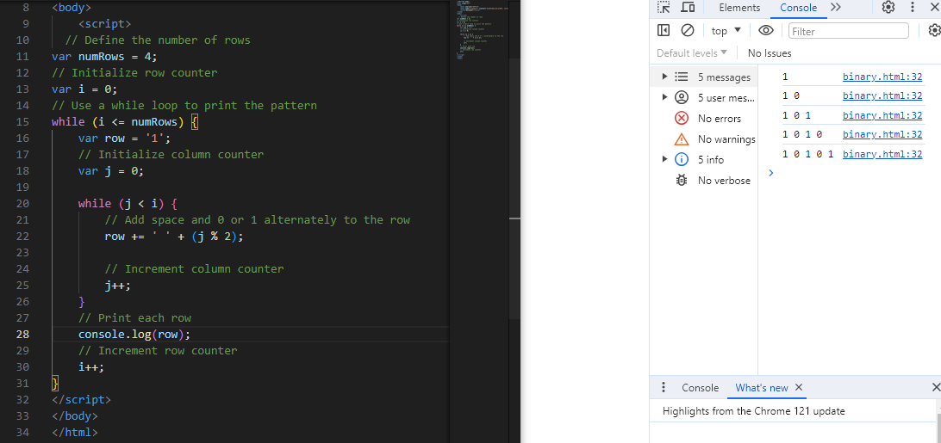

2)A

B C

D E F

G H I J

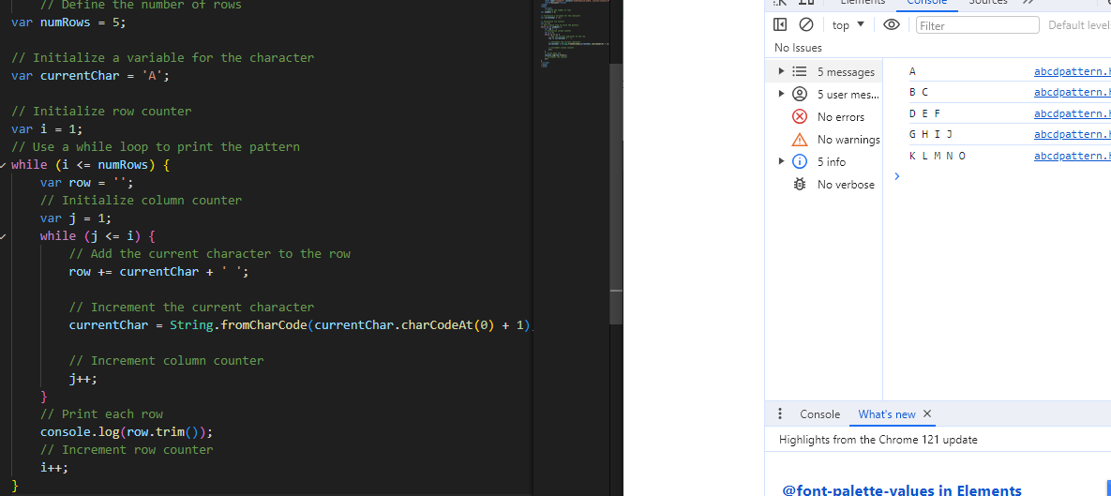

3) 1

2 3

4 5 6

7 8 9 10

11 12 13 14 15

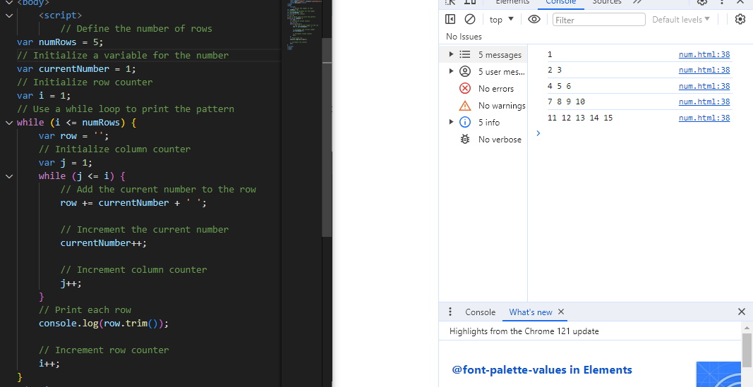

4) *

* *

* * *

* * * *

* * * * *

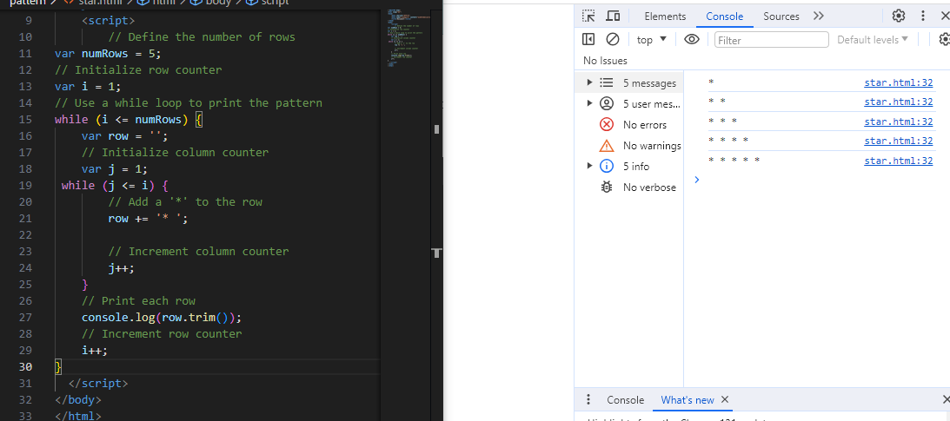

Q.39 Accept 3 numbers from user using while loop and check each numbers palindrome?

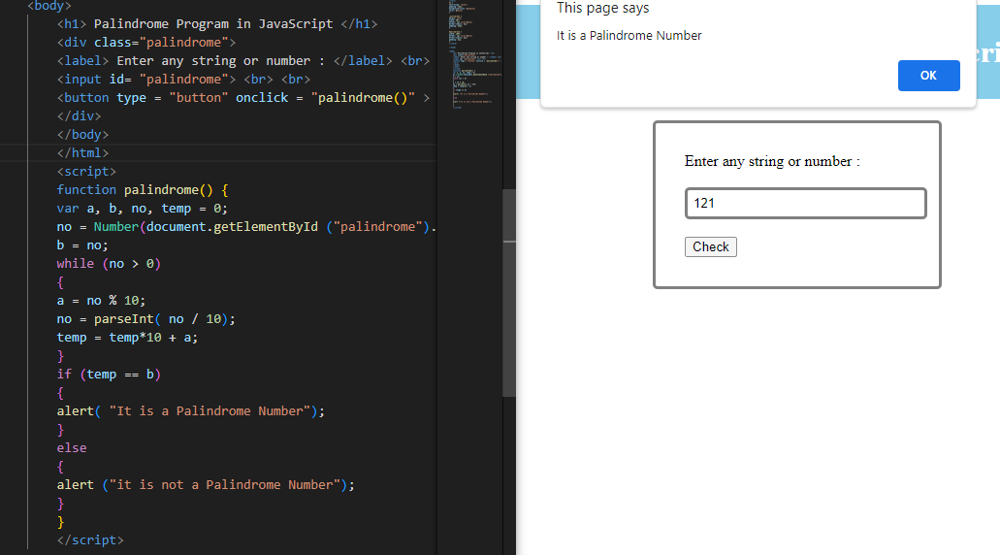

(Array and object Question)

Q.40 Write a JavaScript Program to display the current day and time in the following format. Sample Output: Today is Friday. Current Time is 12 PM: 12 : 22 2 ?

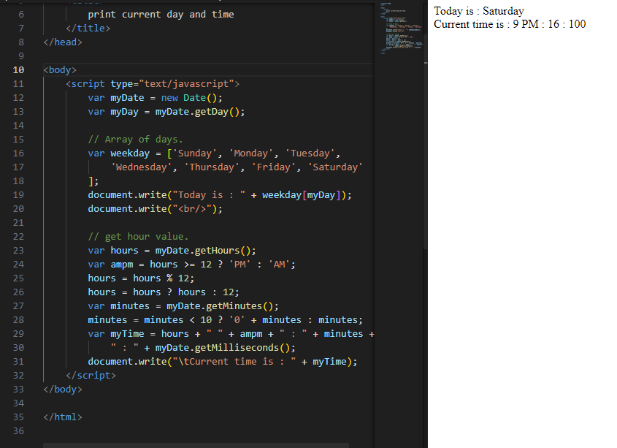

Q.41 Write a JavaScript program to get the current date?

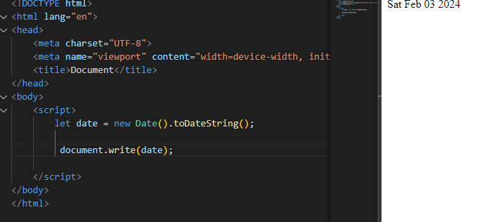

Q.42 Write a JavaScript program to compare two objects?

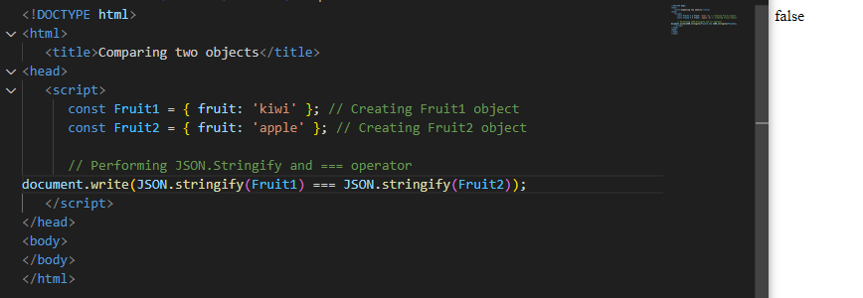

Q.43 Write a JavaScript program to convert an array of objects into CSV string?

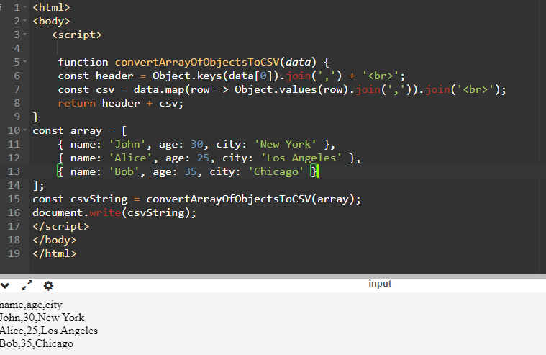

Q.44 Write a JavaScript program to capitalize first letter of a string?

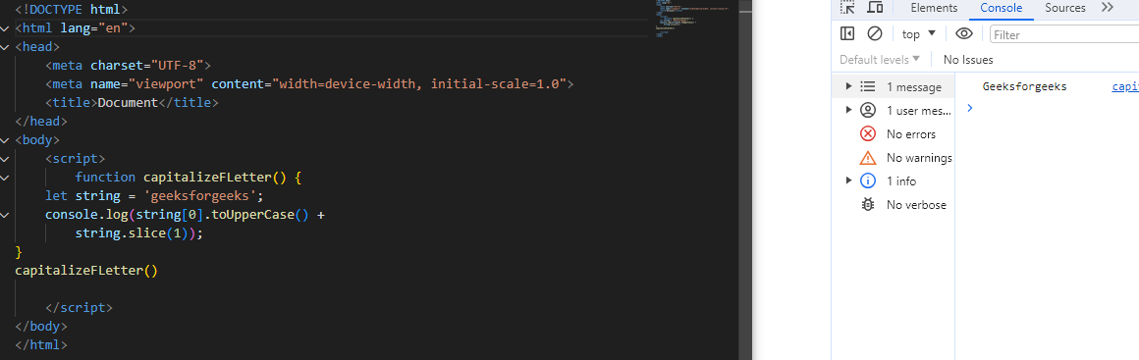

Q. 45 Write a JavaScript program to determine if a variable is array?

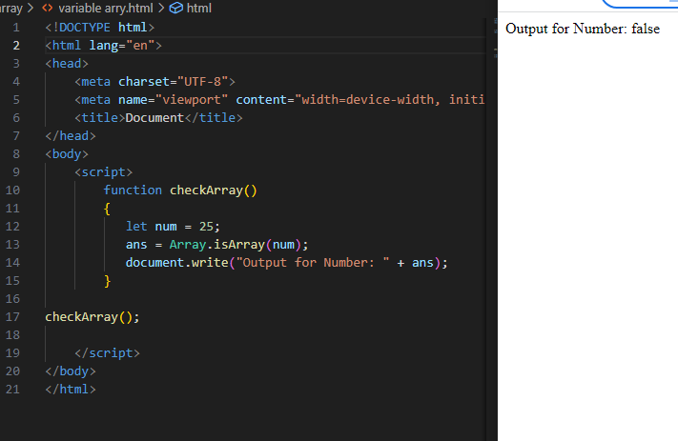

Q.46 Write a JavaScript program to clone an array?

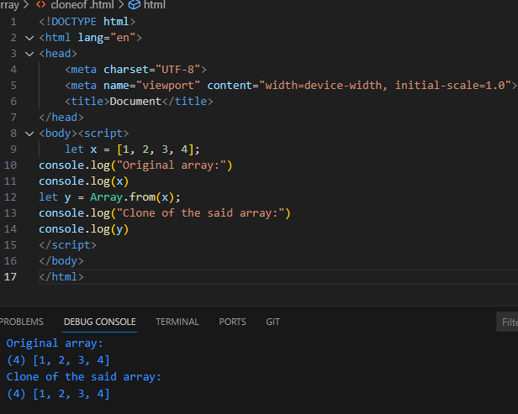

Q.47 )What is the drawback of declaring methods directly in JavaScript objects?

A-47) One potential drawback of declaring methods directly in JavaScript objects is that it

can lead to increased memory usage, especially when you have multiple instances of

the object.

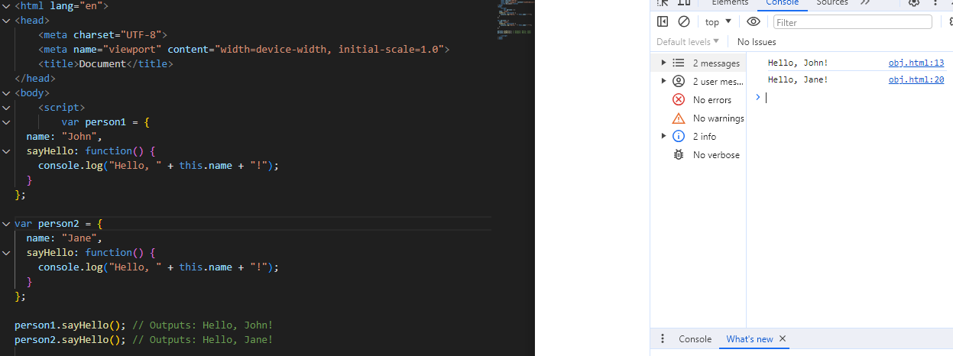

Q.48 Print the length of the string on the browser console using console.log()?

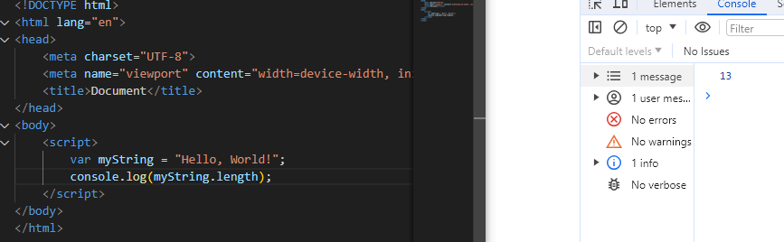

Q.49 Change all the string characters to capital letters using toUpperCase() method?

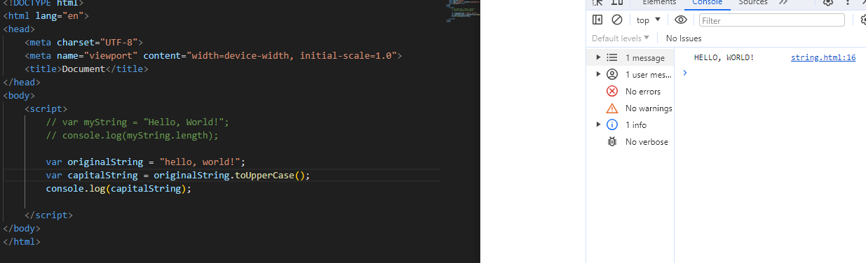

Q.50 What is the drawback of declaring methods directly in JavaScript objects?

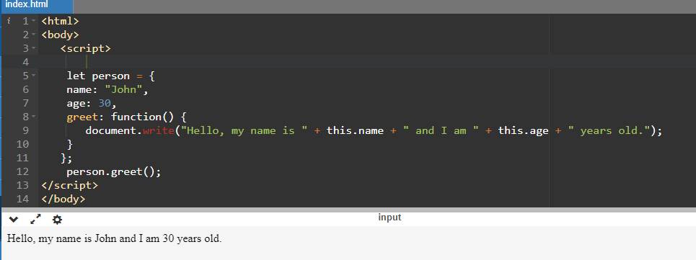

Q.51 Write a JavaScript program to get the current date.

Expected Output: mm-dd-yyyy, mm/dd/yyyy or dd-mm-yyyy, dd/mm/yyyy?

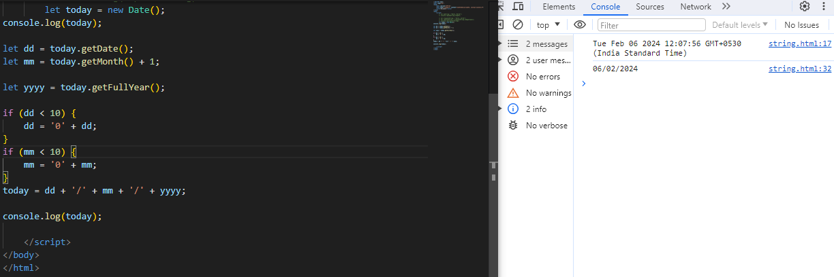

Q.52 Use indexOf to determine the position of the first occurrence of a in 30 Days Of JavaScript?

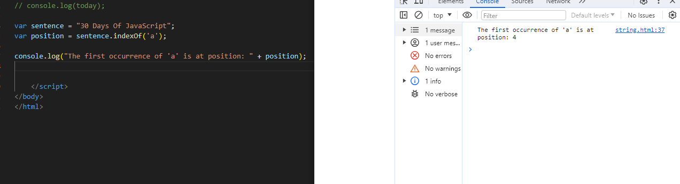

Q.53 Use lastIndexOf to determine the position of the last occurrence of a in 30 Days Of JavaScript?

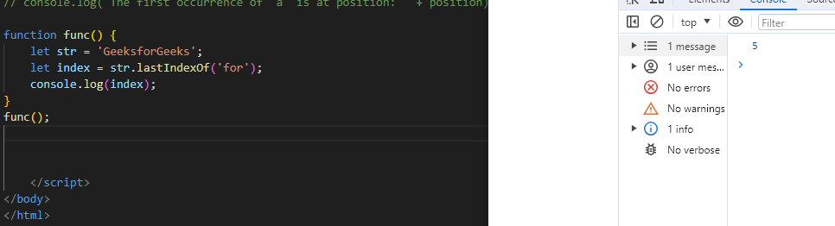

Q.54) Form Validation in JS?

A-54) **Form validation** is the process of verifying that the data entered into an **HTML form** is accurate, complete, and meets the specified criteria.

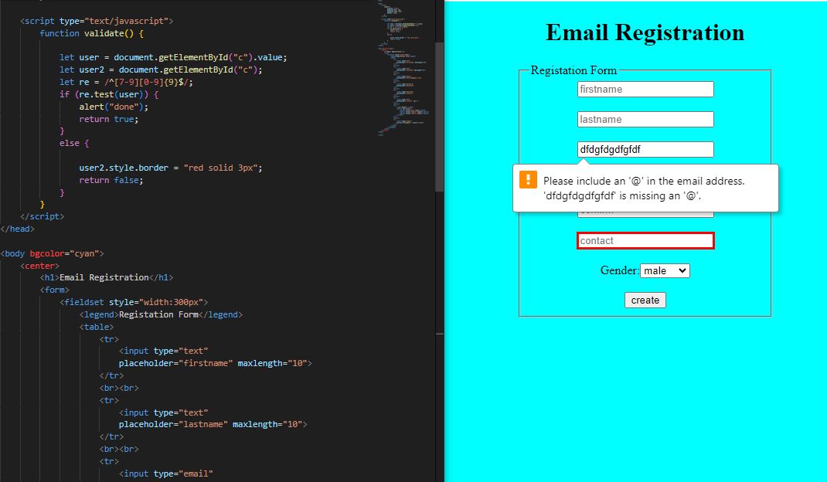

Q.55 Form in Email, number, Password, Validation?

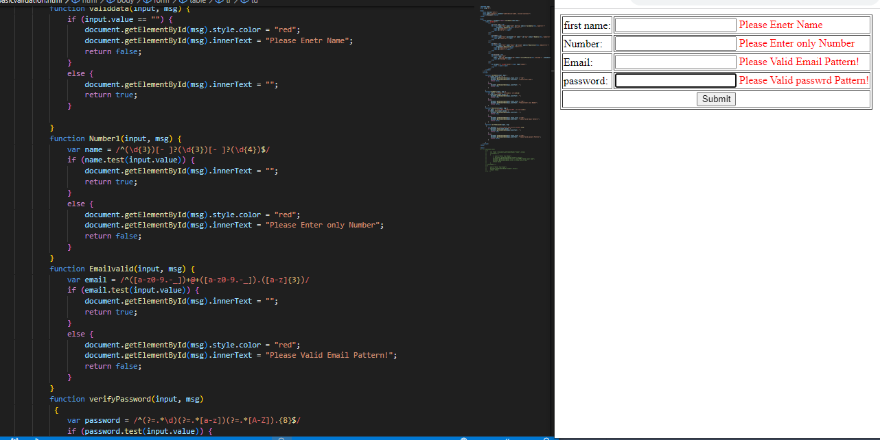

Q.56 Dynamic Form Validation in JS?



Q.57) how many type of JS Event? How to use it?

A-57)JavaScript has Event to provide a dynamic interface to a webpage. These events are

hooked to element in the Document object model.

**Common JavaScript Events**

* **Mouse Events**: Event Performed. Event Handler. Description. click. onclick. ...
* **Keyboard Events**: Event Performed. Event Handler. Description. Keydown & Keyup. ...
* **Form Events**: Event Performed. Event Handler. Description. focus. ...
* **Window or Document Events**: Event Performed. Event Handler. Description. load.

**onclick Event Type :**

This is the most frequently used event type which occurs when a user clicks the left

button of his mouse. You can put your validation, warning etc., against this event type.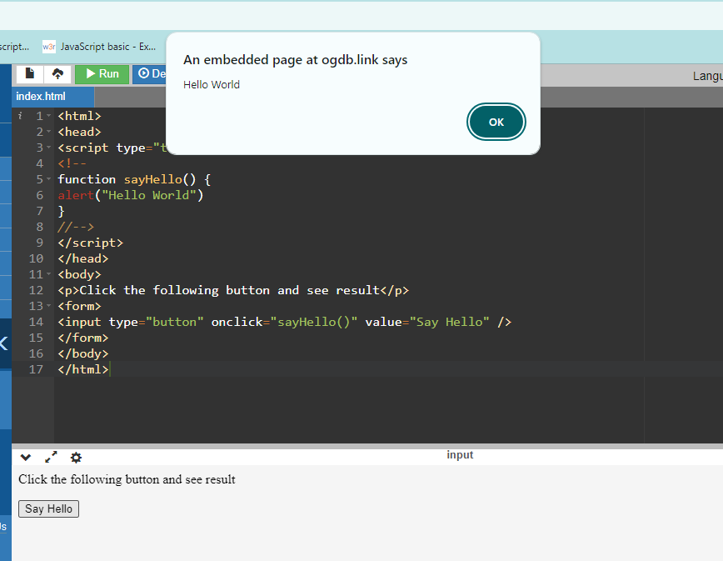

**onsubmit Event type**

onsubmit is an event that occurs when you try to submit a form. You can put your

form validation against this event type.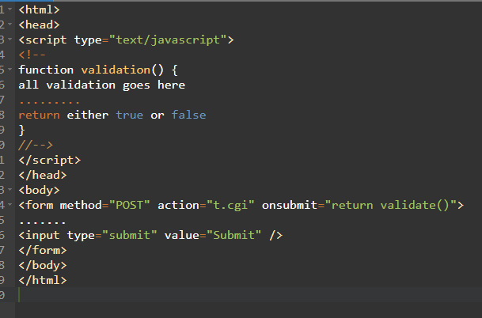

Q.59 What is Bom vs Dom in JS?

| Document Object Model (DOM) | Browser Object Model (BOM) |
| --- | --- |
| It mainly focuses on the structure of the displayed document. | It mainly focuses on browser-specific functionality. |
| It facilitates a standardized interface to access and modify the elements and content of an HTML or XML document. | It allows JavaScript to interact with browser features beyond the scope of manipulating the document structure. |
| When an HTML document gets loaded in the browser, then it becomes a document object. | In this case, the window object will be created automatically by the browser. |
| It facilitates access and manipulation, along with dynamically updating the structure, content, and styling of the web document. | It facilitates the different functionality for governing the browser window, handling the navigation, managing history, and accessing browser-related information. |
| It provides direct access control to the content of the web document, along with permitting the traversal and modification of its elements and attributes. | It doesn’t have any access to the content of the web document directly. |

Q.60 Array vs object defences in JS?

|  |  |
| --- | --- |
| **Array** | **Object** |
| Arrays are a special type of variable that is also mutable and can also be used to store a list of values. | Objects represent a special data type that is [mutable](https://gomakethings.com/immutability-in-javascript/) and can be used to store a collection of data. |
| We use arrays whenever we want to create and store a list of multiple items in a single variable. | Objects are used to represent a “thing” in your code. That could be a person, a car, a building, a book, a character in a game — basically anything that is made up or can be defined by a set of characteristics. |
| Arrays use [zero-based indexing](https://developer.mozilla.org/en-US/docs/Web/JavaScript/Reference/Global_Objects/Array#Accessing_array_elements), so the first item in an array has an index of 0, the second item an index of 1, and so on. | Properties in objects can be accessed, added, changed, and removed by using either **dot** or **bracket** notation. |

Q.61 Split the string into an array using split() Method?

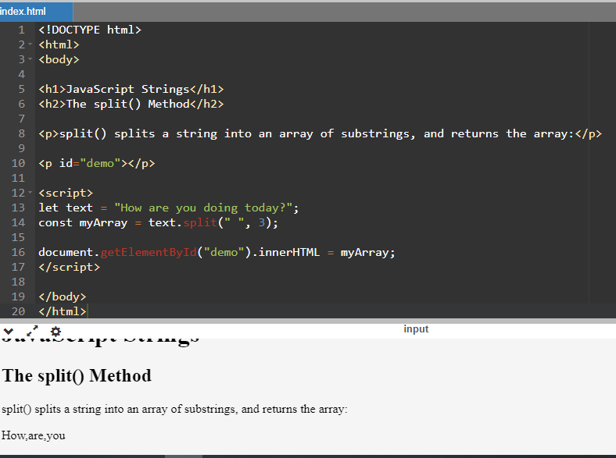

Q.62 Check if the string contains a word Script using includes() method?

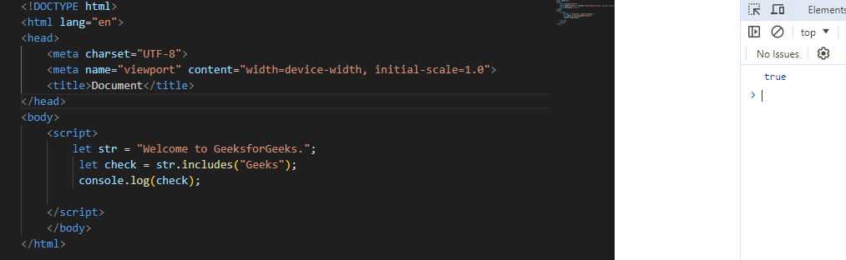

Q.63 Change all the string characters to lowercase letters using to Lowercase () Method.

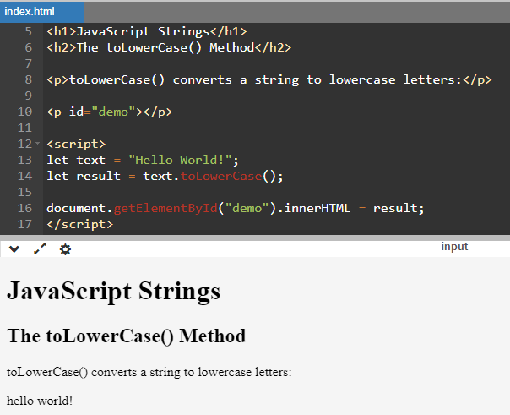

Q.64 What is Character at index 15 in ’30 Days of JavaScript’ string? Use char At () method.

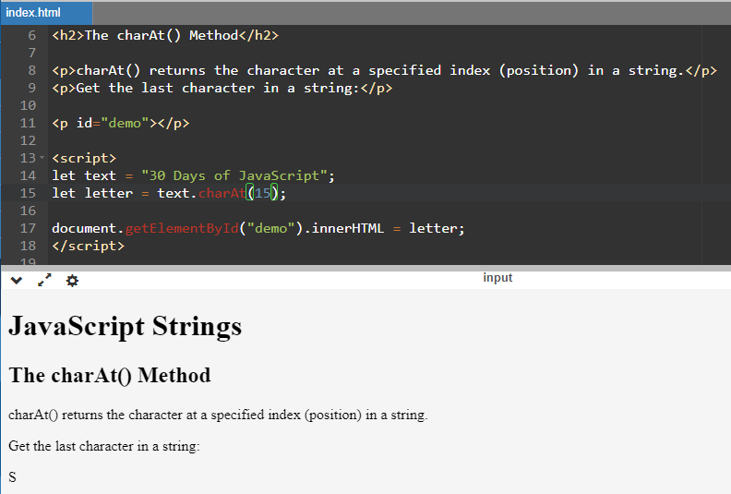

Q.65 copy to one string to another string in JS?

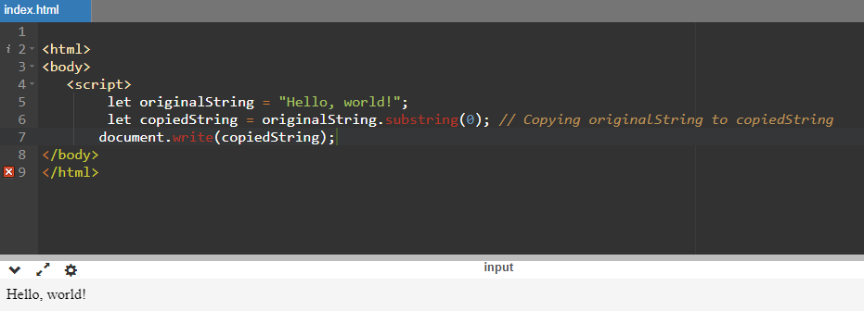

Q.66 Find the length of a string without using library Function?

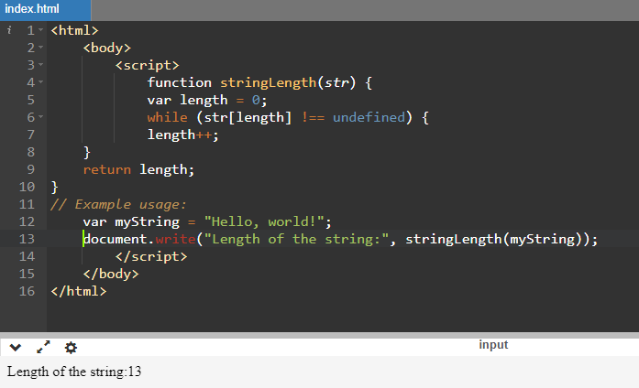

Q-1) What is JavaScript?

1. ***J*avaScript is a scripting language** that enables you to create dynamically updating

content, control multimedia, animate images, and pretty much ...

Q-2) What is the use of isNaN function?

A) The JavaScript isNaN () Function is used to check whether a given value is

an illegal number or not.

Q-3) What is negative Infinity?

A) Negative Infinity is special num is returned when an arithmetic operation or

mathematical generates a negative value greater than the largest representable

JavaScript.

Q-4) Which company developed JavaScript?

1. JavaScript was originally developed by Brendan Erich at Netscape Communications

Corporation.

Q-5) What are undeclared and undefined variables?

A) **Undefined:** it occurs when a variable has been declared but has not been assigned

any value. Undefined is not a Keyword.

B) Undeclared: it occurs when we try to access an variable that is not initialized or

declared earlier using the var or const keyword.

Q-6) Write the code for adding new elements dynamically?

A)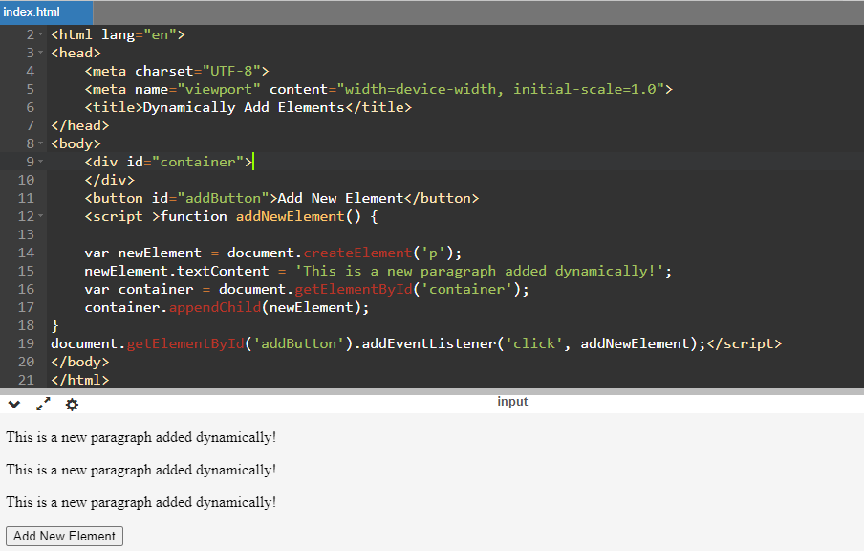

Q-7) What is the difference between View State and Session State?

A)

| **View State** | **Session State** |
| --- | --- |
| Maintained at page level only. | Maintained at session level. |
| View state can only be visible from a single page and not multiple pages. | Session state value availability is across all pages available in a user session. |
| It will retain values in the event of a post back operation occurring. | In session state, user data remains in the server. Data is available to user until the browser is closed or there is session expiration. |
| Information is stored on the client’s end only. | Information is stored on the server. |

Q-8) What is = = = operator?

A) The strict equality (= = =) operator checks whether its two operands are equal,

returning a Boolean result.

Q-9) How can the style/class of an element be changed?

A)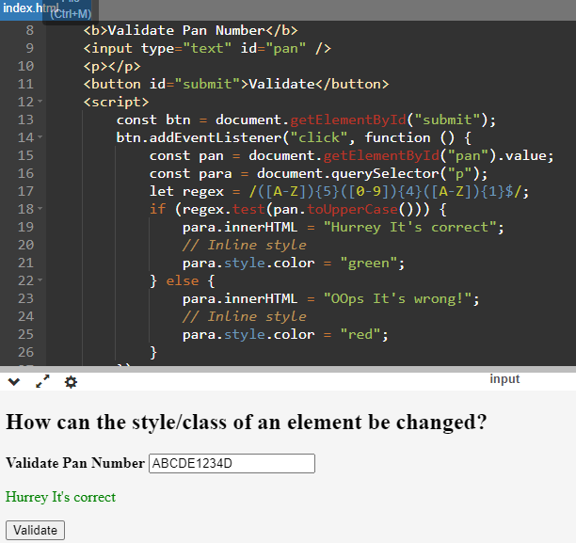

Q-10) How to read and write a file using JavaScript?

## **Write operation on a file**

After the File System file is imported then, the **writeFile ()** operation is called. The

**writeFile ()** method is used to write into the file in JavaScript.

## **Reading from the file**

After the File System module is imported, the reading of the file in JavaScript can be done by using the **readFile ()** function.

Q-11)What are all the looping structures in JavaScript?

A) There are kind of loops you will find in JavaScript.

1)For Loop: The **for** loop repeats a block of code a specified number of times. It consists of three parts: initialization, condition, and increment/decrement.

for(initialization; condition; increment/decrement){

//code of block to be execute

}

2) **while loop**: The **while** loop repeats a block of code while a specified condition is true.

while(conidition){

//code block to be executed

}

3) **do...while loop**: The **do...while** loop is similar to the **while** loop, but the condition is

checked after the block of code is executed. This ensures that the code block is executed

at least once.

do{

//code of block to be executed

}while(condition);

4) **for...in loop**: The **for...in** loop iterates over the enumerable properties of an object, in

arbitrary order. It is used for iterating over the properties of an object.

for(variable in object)

{

//code block to be executed

}

5) there's also the **for...of** loop which iterates over iterable objects like arrays, strings

maps, sets, etc.

for(variables of iterable)

{

//code block to be executed

}

Q-11) How can you convert the string of any base to an integer in JavaScript?

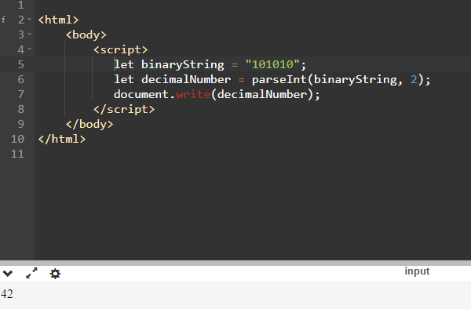

Q-12) What is the function of the delete operator?

A)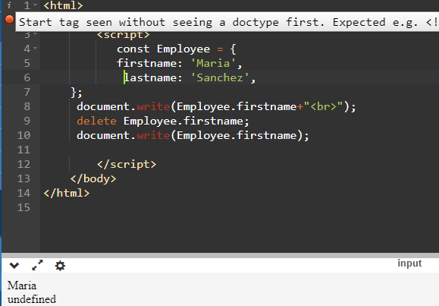

Q-13) What are all the types of Pop up boxes available in JavaScript?

A) There are three types of JavaScript:

A) Alert Box:

The ‘alert ()’function is used to display an alert dialog box with a specified

message or ok button.

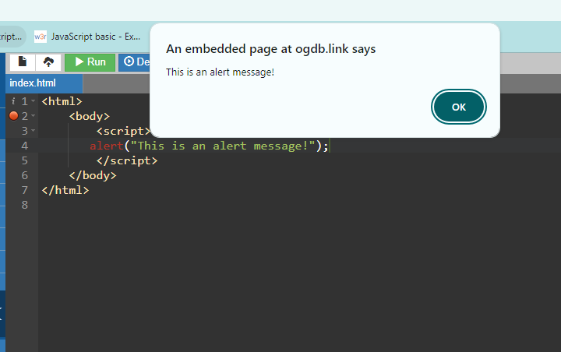

Q-14) What is the use of Void (0)?

A) The void operator evaluates an expression and returns undefined. By running void (0) in the URL JavaScript code, nothing is evaluated or return.

Q-15) How can a page be forced to load another page in JavaScript?

A)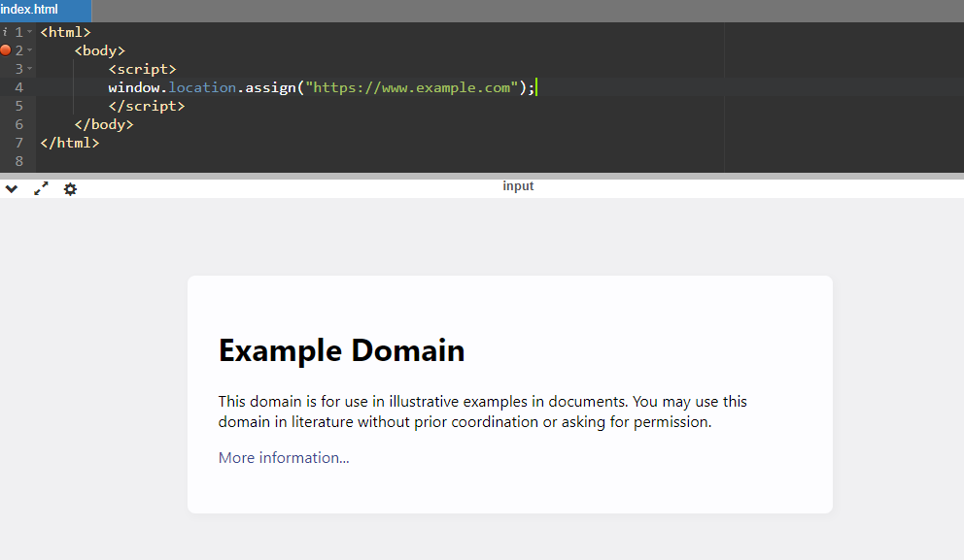

Q-16) What are the disadvantages of using innerHTML in JavaScript?

A)

* **The use of innerHTML very slow**
* **Preserves event handlers attached to any DOM elements**
* **Content is replaced everywhere**
* **Appending to innerHTML is not supported**